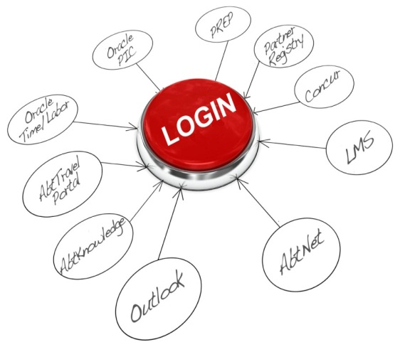
Single Sign-On is Here!

You are now on the Single Sign-On (SSO) System! To complete the process, please complete this document as you log in:

Your Name: ____________________________________________

Follow the steps below. Using your Abtremote password, log in to:

- Abtremote (if you have never logged in to Abtremote, contact your IT Manager for help)
- Outlook email (with your email address and Abtremote password)
- Lync (with your email address and Abtremote password)
- Oracle (If you are an Abt employee )
- Abt email on your Blackberry, iPhone or iPad (if you use one)
- Then, complete the following checkboxes based on your results:
 | Works OK | Does Not Work
Outlook Email
Oracle (if you are an Abt employee)
Your IT Manager will collect this completed document. If you have any questions or difficulties, please contact your IT Manager. Thank you for your cooperation and doing your part to complete the Single Sign-On implementation!

Single Sign-On is Here!

You are now on the Single Sign-On (SSO) System! To complete the process, please complete this document as you log in:

Your Name: ____________________________________________

Follow the steps below. Using your Abtremote password, log in to:

- Abtremote (if you have never logged in to Abtremote, contact your IT Manager for help)
- Outlook email (with your email address and Abtremote password)
- Lync (with your email address and Abtremote password)
- Oracle (If you are an Abt employee )
- Abt email on your Blackberry, iPhone or iPad (if you use one)
- Then, complete the following checkboxes based on your results:
 | Works OK | Does Not Work
Outlook Email
Oracle (if you are an Abt employee)
Your IT Manager will collect this completed document. If you have any questions or difficulties, please contact your IT Manager. Thank you for your cooperation and doing your part to complete the Single Sign-On implementation!

